**Getting started with I2C LCD Interface**Compiled by Johan Conradie - Micro Robotics - 2014

This LCD2004 is a great I2C interface for 2x16 and 4x20 LCD displays. With the limited pin resources, your project may be out of resources using normal LCD shield. With this I2C interface LCD module, you only need 2 lines (I2C) to display the information. If you already has I2C devices in your project, this LCD module actually cost no more resources at all. Fantastic for Arduino based project.

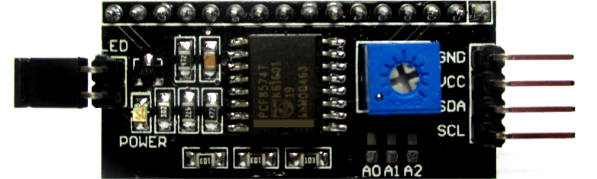

The LCD2004 board utilized the PCF8574 I/O expander. This nifty little chip provides eight bits of parallel I/O addressable by a I2C bus. **All the address leads are pulled high to +5V**, so the LCD2004 board’s I2C address is permanently fixed at 7. To change the address, simply close the address lines jumper, (see table below). To write to the device, simply address the board and write an eight bit value which is then presented on the output pins of the PCF8574, which, in this case, are connected to the HD44780 based LCD screen.

**LCD2004 Board Layout & I2C Address Setup**

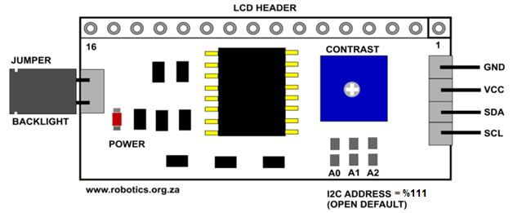

**NOTE: The Default Address is %111. The Address Bridges are NOT in LSB Order!!!**

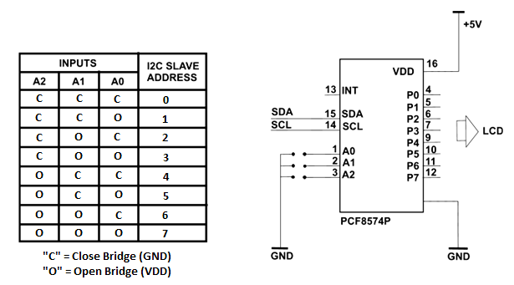

**Address Pins are pulled up to +5V on the board.**

**Remember!**

The PCF8574 has a different Slave Address then the PCF8574A. See the Datasheet.